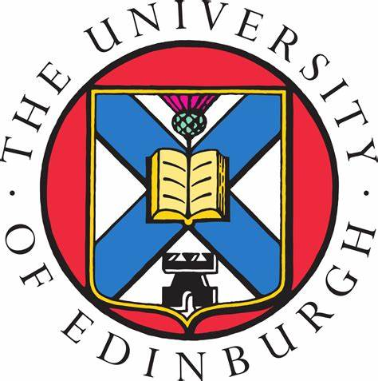 | The University of Edinburgh  College of Medicine and Veterinary Medicine

PReDICTED GRADES REQUEST FORM
GRADUATE APPLICATIONS

Please complete this form electronically where possible

Name of Applicant:
UCAS Personal ID Number:
Institute Name & Address:

Level of Degree (e.g. Bachelors, Honours, Integrated Masters, etc.)

Exact Title of Degree (not translation) | Subject/Major | Predicted Final, Overall Grade/Classification/GPA

Teacher’s/Tutor’s Name: | Teacher’s/Tutor’s Signature: | Date:

